**Final submission of Coursework 1**

**(A gaming website)**

**Table of contents**

**Page no. Title**

1. **Website introduction**

**2-5 Screenshot of all pages**

**6 About the game**

**7 How the game works**

**8 Registration and login**

**9 Input validation**

**10 Ranking functionality**

**11 Project summary**

**Website Introduction**

This project is a simple gaming website meant for my coursework. The website has few features such as user registration and navigation bar. It consists of five pages:

* **Home page**
* **Game page**
* **Leaderboard page**
* **Registration page**
* **About page**

1

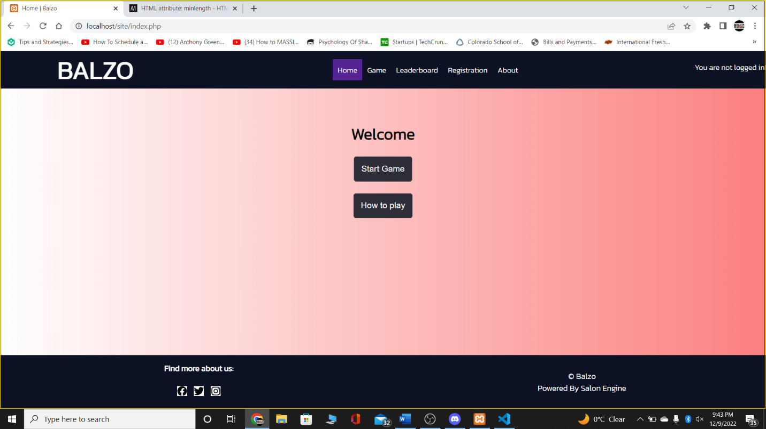

2

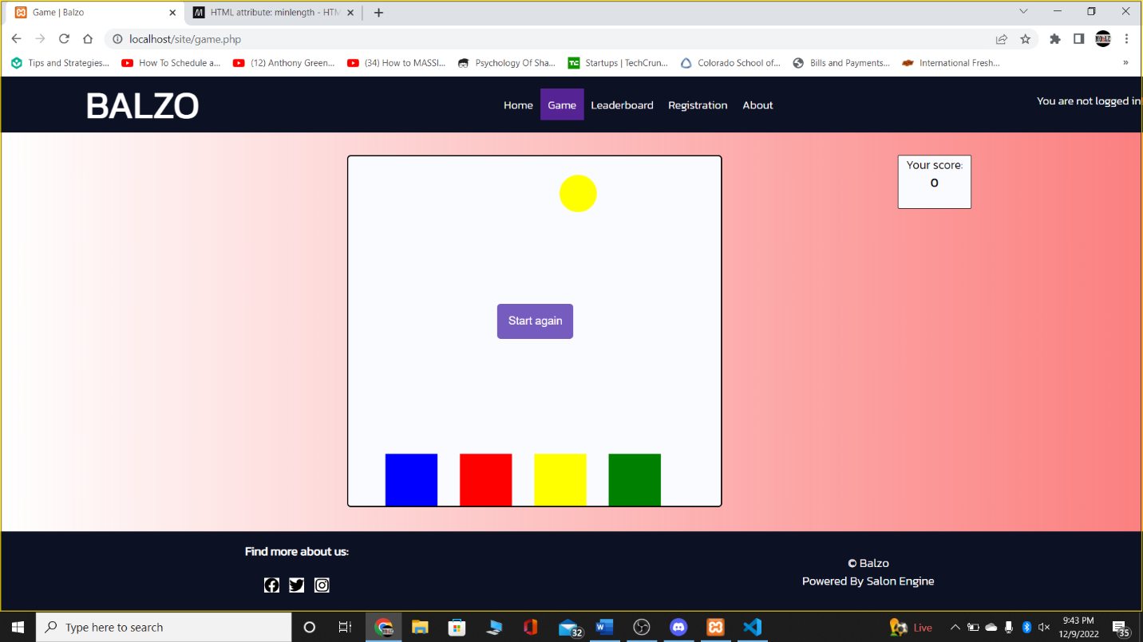

3

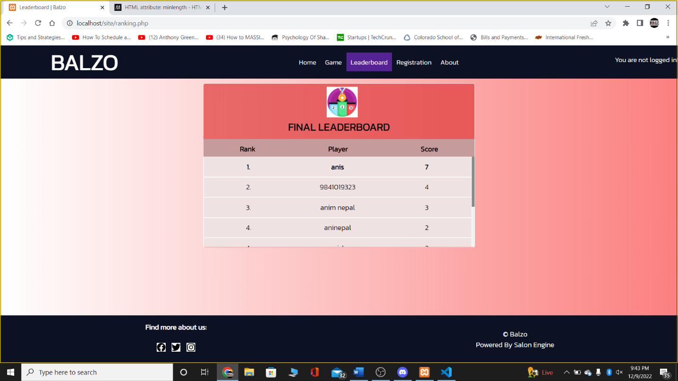

3

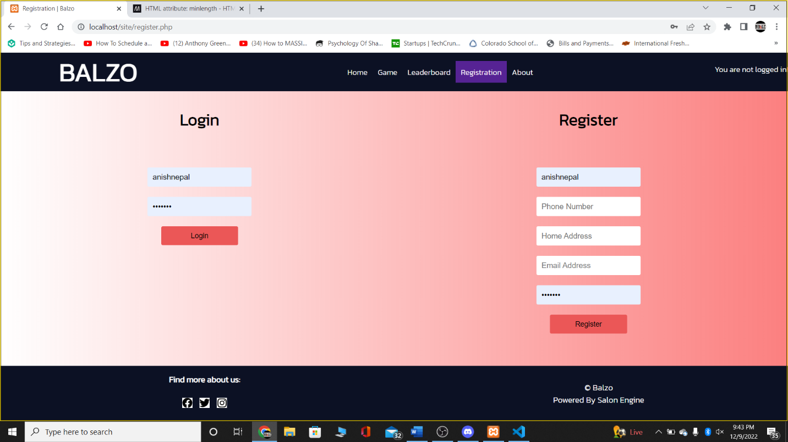

4

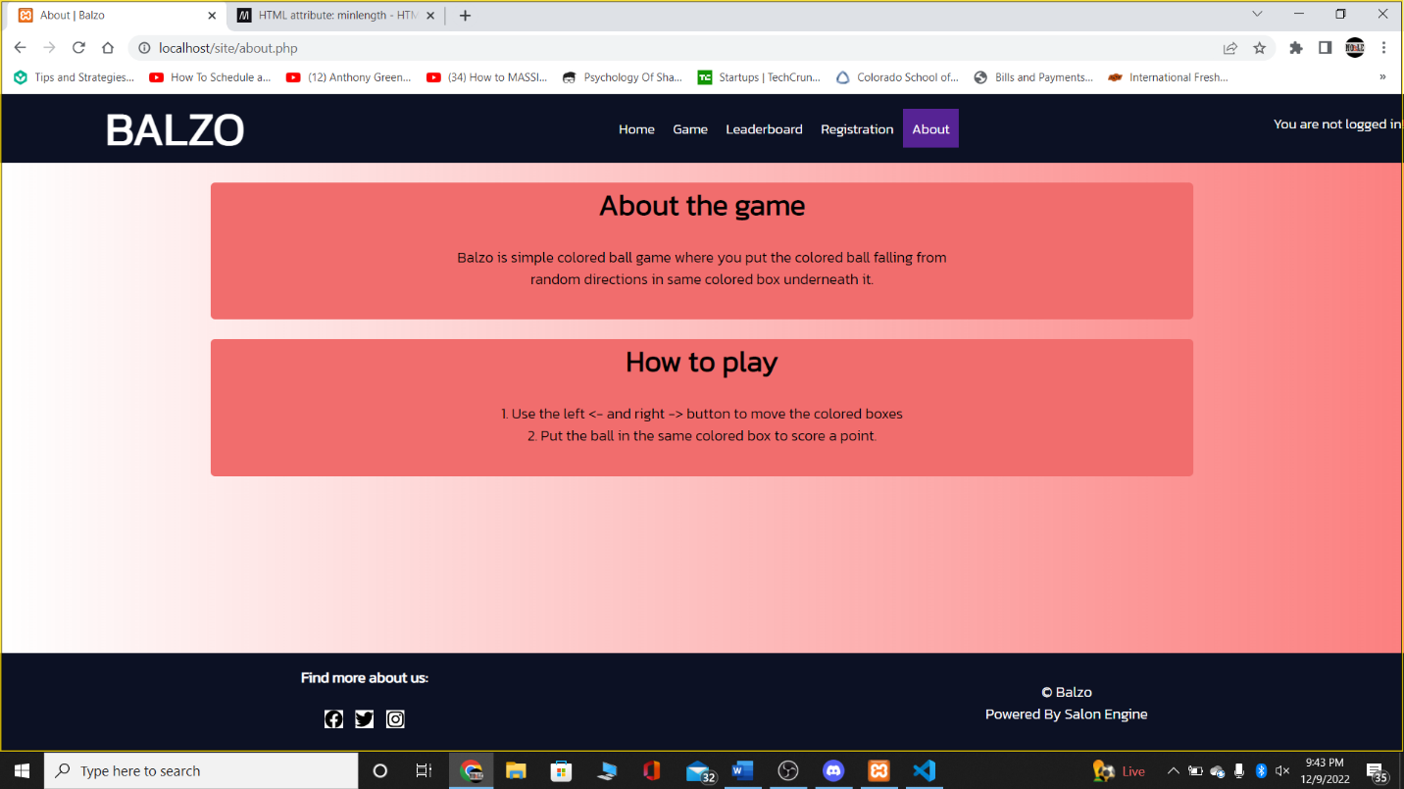

5

**About the game**

The game which I included in this coursework gaming website is a simple ball game built using HTML, CSS, JavaScript, and some PHP. This game “Balzo” consists of a 1 out of 4 colored ball falling randomly from different points. Underneath the ball lies four differently colored boxes where user must collect the ball. I used HTML canvas for drawing these ball and basket and JavaScript to bring functionality to his game.

6

**How the game works**

User needs to first login to play the game. As 1 out of 4 colored balls keeps from randomly selected points inside the canvas, the user needs to be able to collect the ball in same colored box to score a point. User must use left or right button to go left or right to the canvas. As such, each ball collected will secure 1 point. If user fails to do so, the “start again” button appears where the user to play again and the score will be reset to 0. If the score was greater than his stored scored in local storage, the game updates his record which can be displayed in “Leaderboard page”.

7

**Registration and login**

The user must visit “Registration page” for logging in. User needs to submit his full/username, phone number, email address and password to register to the website. All these details are stored in local storage as an object. Hence, multiple users can register or login. Login has been made quite simple with user just submitting their username and password.

**8**

**Input Validation**

For input validation, I have sticked to HTML5 validation for user email address and use minlength attributes for password. Empty inputs are prohibited using Javascript code.

**9**

**Ranking functionality**

Ranking is be done topScore key/value pairs. A sorting algorithm is first used to arrange the score in descending order. Then after that, each score that matches the score will be displayed on the Leaderboard page. Note: users with same score are ranked alphabetically by default.

**10**

**Project Summary**

To sum up, my coursework 1 is a simple gaming website that includes a simple ball game which I built using HTML, CSS, Javascript and little PHP.

**11**